The Islamia University of Bahawalpur
Department of Information Technology
Faculty of Computing


SOFTWARE DESIGN DOCUMENT (SDD)
for
Venture Bridge
Version 1.0

By
Muneeba Shaheen #1076
Section 2M
Session Spring 2023 – 2027
Supervisor
Prof. Wahaj Ali
Bachelor of Information Technology
Revision History
Date | Description | Author | Comments
June 5, 2026 | Version 1.0 | Muneeba Shaheen | Initial SDD document created

Document Approval
The following Software Design Document (SDD) has been accepted and approved by the following:
Signature | Printed Name | Title | Date
 | Prof. Wahaj Ali | Supervisor | June 5, 2026

Table of Contents

1. Introduction 4
1.1. Purpose 4
1.2. Scope 4
1.3. Overview 4
1.4. Reference Material 4
1.5. Definitions and Acronyms 4
2. System Overview 5
3. System Architecture 5
3.1. Architectural Design 5
3.2. Decomposition Description 5
3.3. Design Rationale 6
4. Data Design 6
4.1. Data Description 6
4.2. Data Dictionary 7
5. Component Design 8
6. Human Interface Design 8
6.1. Overview of User Interface 8
6.2. Screen Images 8
6.3. Screen Objects and Actions 9
7. Requirements Matrix 10
8. Appendices 10

1. INTRODUCTION

1.1. Purpose
This Software Design Document describes the architecture and system design of Venture Bridge. It is intended to explain how the startup-investor marketplace platform is organized into architecture, components, data model, user interface, security, deployment, and future scalability areas.

1.2. Scope
Venture Bridge is a startup-investor marketplace platform connecting entrepreneurs with investors through profiles, pitch listings, search, dashboards, and real-time messaging. The scope includes authentication, 2FA, profiles, pitch submission, attachments, search/filtering, chat, and dashboards. The objective is to simplify startup-investor discovery and communication.

1.3. Overview
This document follows the provided Software Design Document template. It includes the system overview, system architecture, data design, component design, human interface design, requirements matrix, and appendices.

1.4. Reference Material
This document is based on the Venture Bridge Software Requirements Specification (SRS) Version 1.0 and the approved project proposal submitted to the Department of Information Technology Department, IUB.

1.5. Definitions and Acronyms
Term / Acronym | Definition
SDD | Software Design Document
2FA | Two-Factor Authentication
JWT | JSON Web Token used for authentication
RBAC | Role-Based Access Control permissions
OTP | One-Time Password sent through Resend API
API | Application Programming Interface
UI | User Interface
CDN | Content Delivery Network for assets

2. SYSTEM OVERVIEW
Venture Bridge is designed as a modern web application where founders publish investment opportunities and investors discover, evaluate, and communicate with startups. The system supports profiles, pitch listings, search, dashboards, and real-time messaging. Its design is based on a layered client-server architecture.

3. SYSTEM ARCHITECTURE

3.1. Architectural Design
Venture Bridge follows a layered client-server architecture. Users interact with the React.js frontend, which communicates with the Node.js API. The API connects with MongoDB for data storage, Storage for file attachments, and Socket.IO for real-time chat.
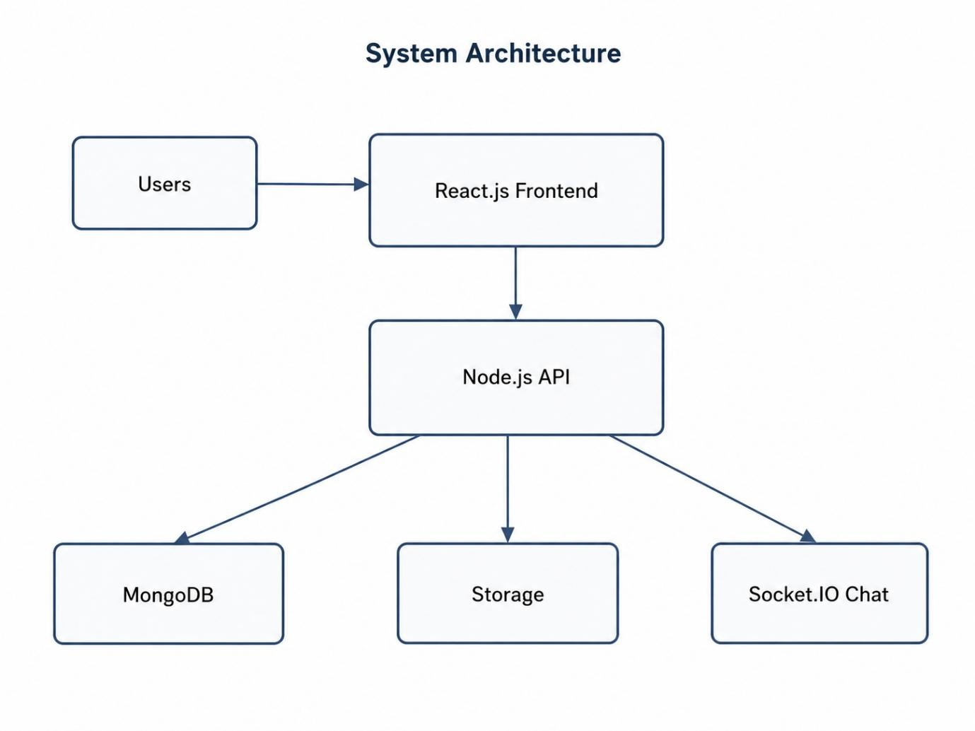

3.2. Decomposition Description
The system is decomposed into major subsystems based on the functions described in the SDD: authentication and 2FA, profile management, pitch submission and attachments, search/filtering, real-time chat, and dashboards.

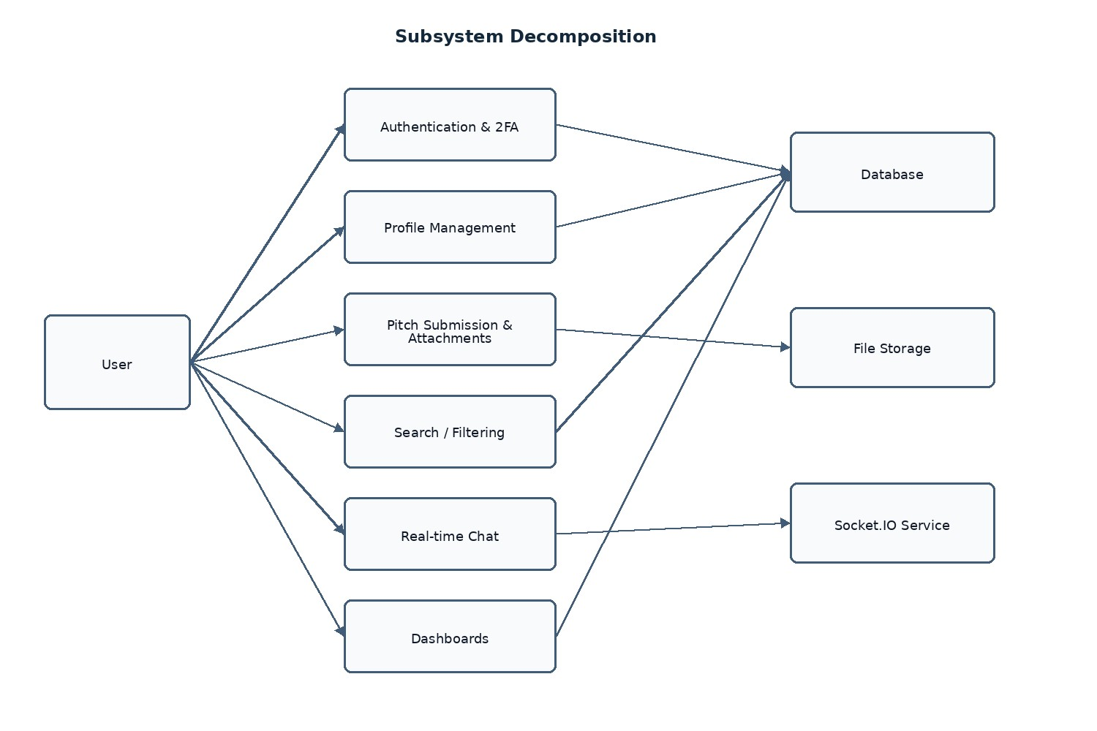
The backend architecture includes an API Layer to handle requests, a Service Layer to handle business logic, a Data Layer to persist entities, and a Realtime Layer to manage chat.

3.3. Design Rationale
The layered client-server architecture was selected because it separates the user interface, API handling, business logic, data persistence, and real-time communication. This makes the system easier to maintain, extend, and deploy while keeping the design understandable.

4. DATA DESIGN

4.1. Data Description
The core entities of the system are Users, Profiles, Pitches, Messages, and Attachments. These entities support account access, user information, pitch details, chat communication, and file handling.
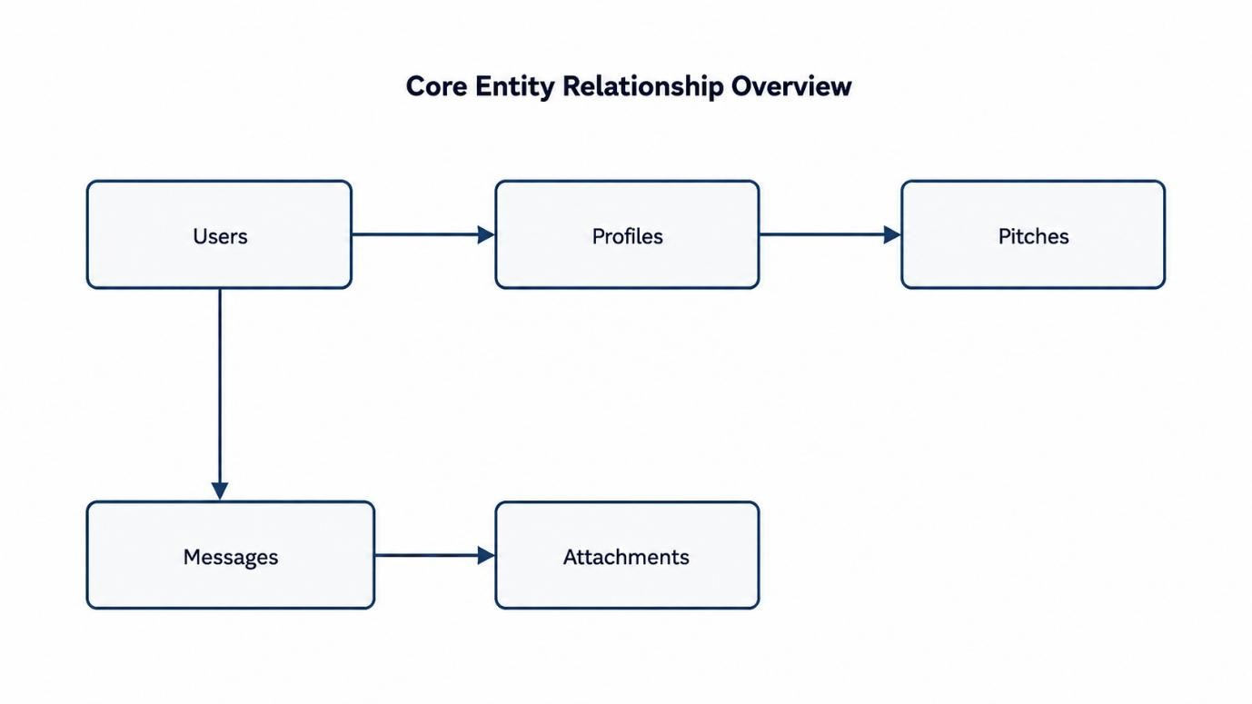

4.2. Data Dictionary

Entity / Data Item | Type | Description
Users | Entity | Stores user account information for the platform.
Profiles | Entity | Stores user profile information.
Pitches | Entity | Stores pitch listing information published by founders.
Messages | Entity | Stores real-time message information.
Attachments | Entity | Stores file-related information for pitch attachments.
JWT authentication | Security data | Used for authenticated access.
bcrypt passwords | Security data | Used for secure password storage.
OTP via Resend API | Security data | Used for two-factor authentication.
RBAC permissions | Security data | Used to manage role-based access.

5. COMPONENT DESIGN
Component | Main Responsibility
API Layer | Handles requests from the frontend.
Service Layer | Handles business logic.
Data Layer | Persists system entities.
Realtime Layer | Manages chat communication.
Authentication and 2FA | Supports login security using JWT authentication and OTP via Resend API.
Profile Management | Supports user profile setup and management.
Pitch Submission and Attachments | Supports pitch publishing and file attachment handling.
Search / Filtering | Supports discovery of pitch listings.
Dashboards | Shows role-based platform activity to users.
Deployment Components | Frontend on Vercel, backend on Render/AWS, MongoDB Atlas, object storage for files, and CDN for assets.

6. HUMAN INTERFACE DESIGN

6.1. Overview of User Interface
The user interface allows users to move through the main system screens: Home, Login/Register, Profile Setup, Pitch Listing, Pitch Detail, Chat, Entrepreneur Dashboard, and Investor Dashboard. These screens support the expected project functions from the user perspective.

6.2. Screen Images
- Home Page
- Login / Register
- Profile Setup
- Pitch Listing
- Pitch Detail
- Chat
- Entrepreneur Dashboard
- Investor Dashboard
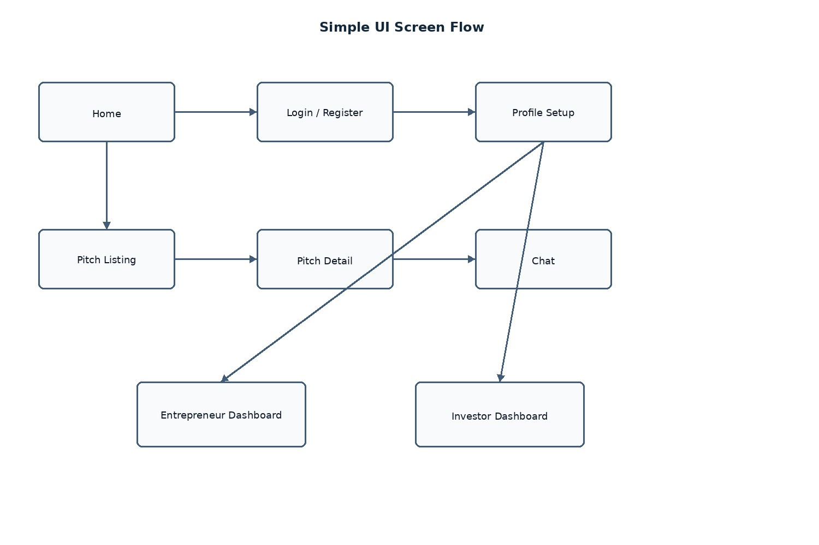

6.3. Screen Objects and Actions
Screen | Main Objects / Actions
Home | Entry point for users.
Login/Register | Allows users to access or create an account.
Profile Setup | Allows users to set up profile information.
Pitch Listing | Allows users to view pitch listings and use search/filtering.
Pitch Detail | Allows users to view full pitch information.
Chat | Allows real-time communication.
Entrepreneur Dashboard | Shows entrepreneur-related activity.
Investor Dashboard | Shows investor-related activity.

Page

7. REQUIREMENTS MATRIX
Requirement | Related Component / Data Structure
Authentication | Authentication and 2FA component, Users entity
2FA | Authentication and 2FA component, OTP via Resend API
Profiles | Profile Management component, Profiles entity
Pitch Submission | Pitch Submission component, Pitches entity
Attachments | Pitch Submission and Attachments component, Attachments entity, object storage
Search / Filtering | Search / Filtering component, Pitches entity
Chat | Realtime Layer, Messages and Conversations entities, Socket.IO Chat
Dashboards | Dashboard component, Users, Profiles, Pitches, Messages, and Conversations entities
Security | JWT authentication, bcrypt passwords, RBAC permissions, secure file validation, HTTPS transport
Deployment | Frontend on Vercel, backend on Render/AWS, MongoDB Atlas, object storage, CDN

8. APPENDICES

8.1 Appendix A: API Endpoint Groups
The backend API is grouped around authentication, profiles, pitches, search, messages, dashboards, and file uploads. Exact endpoint URLs can be finalized during implementation.

8.2 Appendix B: Error Handling
- Invalid email or password.
- OTP has expired. Please request a new one.
- Incorrect OTP. Please try again.
- File upload failed. Please try a different file.
Page
- Only PDF, JPG, and PNG files are accepted.
- No pitches found matching your criteria.
- Connection lost. Reconnecting...

8.3 Appendix C: Glossary
Entrepreneur: A user who submits business pitches. Investor: A user who searches for pitch opportunities and communicates with entrepreneurs. Pitch: A business idea or proposal submitted for investor discovery.

